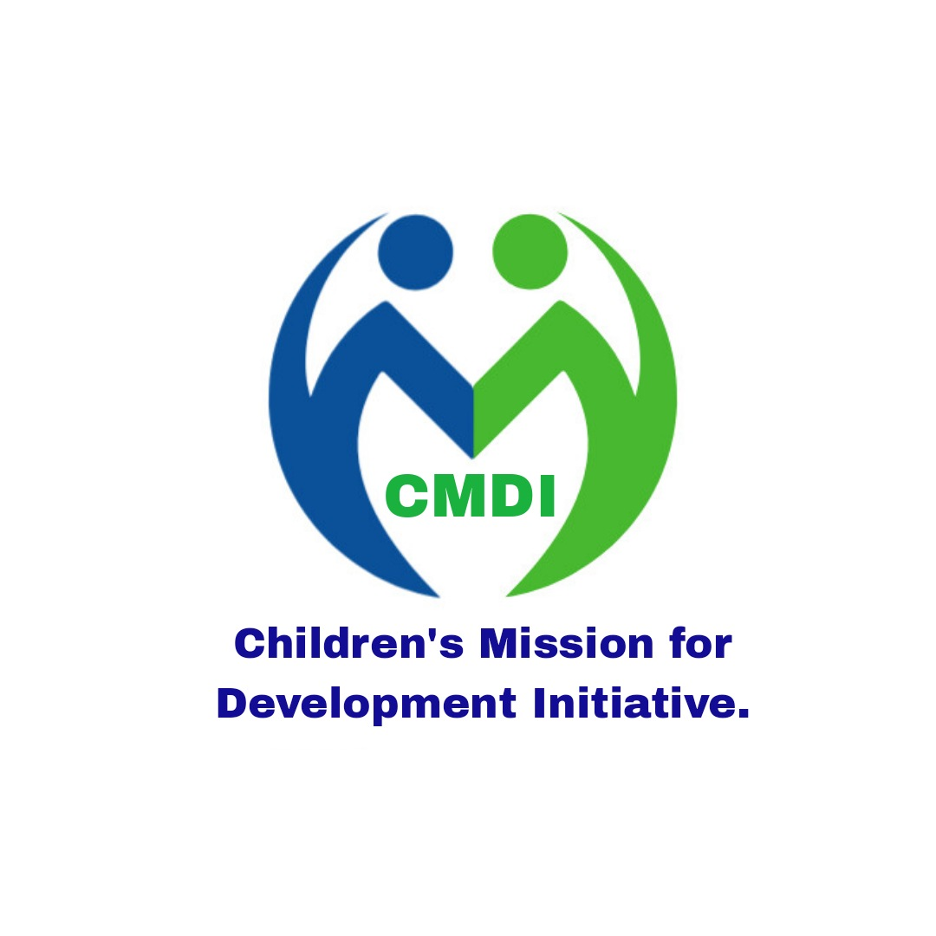

Children's Mission For Development Initiative (CMDI)
Motto: Empowering Children and Transforming Communities.

Profile Overview
Name: Children’s Mission For Development Initiative (CMDI)
Type: Non-Profit, Non-Governmental Organization (NGO)
Founded in: 2022 and officially registered in 2025
Registration Number: 5899,/NGO//2025 Registered under the NGO act of South Sudan.
Field Office, Fangak county
Headquarters: Juba, South Sudan
Website: www.cmdi.org
Email: cmdi67768@gmail.com
Phone: +211929045655

About Us
Children's Mission For Development Initiative (CMDI) is a child-focused, community-driven non-profit organization dedicated to promoting the rights, well-being, and holistic development of vulnerable children. We work to create sustainable change by empowering children, their families, and communities through education, health care, child protection, and economic empowerment initiatives.
CMDI was established in response to the growing challenges faced by children in under-served regions. Our programs aim to break the cycle of poverty and ensure that every child has the opportunity to reach their full potential in a safe and nurturing environment.

Vision
“A South Sudan where every child grows up healthy, educated, protected, and empowered—supported by resilient communities with access to peace, safe water, livelihoods, and essential services.”

Mission
To empower children and communites in south sudanI through education, improved nutrition, safe water and sanitation, and protection services enabling every child to grow, learn and thrive.
Strategic Goal
To strengthen community resilience and child development through integrated services that ensure access to quality education, essential health and nutrition, child protection, peace and conflict resolution, and timely humanitarian assistance.
Aim
To promote the holistic well-being and development of children and their communities in crisis-affected and underdeveloped areas, enabling them to survive, thrive, and become agents of peace and change.

Core Values
- Child centeredness
- Integrity
- Community empowerment
- Equity
- Partnership
- compassion
- inclusiveness
- accountability
- Sustainability

Objectives
- improving access to education. focusing on addressing conflict, poverty, and social barriers, while also investing in infrastructure, teacher training, and inclusive education programs. This includes expanding free education, building school infrastructure, implementing accelerated education programs, and promoting school meals.
- Strengthening healthcare system. This include routine immunization to protect children from preventable diseases. Engaging families and communities, ensuring continuous access to care, and promoting health equity for all children, especially in under-served areas.
- Providing Child protection. This includes addressing violence against children, promoting positive parenting practices, and ensuring access to essential services like education, healthcare, and psychosocial support.
- Improving Water, Sanitation, and Hygiene (WASH) .This requires a multifaceted approach focusing on access to safe water, sanitation facilities, and hygiene education. This involves drilling boreholes, providing water purification solutions, constructing and maintaining latrines, and promoting hygiene practices to enhance WASH management and monitoring.
- Peace-building and reconciliation in communities. Focuses on transforming negative relationships, repairing community structures, and fostering a sense of belonging.
- Youth and Women Empowerment:
  - Vocational training and life skills development
  - Microfinance and income-generating initiatives
  - Mentorship and leadership development.
7. Livelihoods: skills training for youth and parents.
Areas of focus
- Education
- Child Protection
- WASH (water, Sanitation, and Hygiene)
- Emergency Response&Resilience
- advocacy and community Engagement

key partners and donors

CMDI is currently mobilizing resources to implement its flagship “learning for life” programs in Fangak county. We are seeking strategic partners to support planning and co-design of education and child protection

Geographical Focus
CMDI primarily operates in fangak county, Jonglei state, South Sudan, with plans to expand to other under-served counties of Upper Nile Region.
Organization Structure:

Executive Director
- Provides overall leadership and strategic direction.
- Oversees implementation of all programs and projects.
- Liaises with the Board of Directors and donors.
- Leads fundraising and donor engagement.
- Represents CMDI in national and international forums.

Program Manager
- Plans and manages all field programs and activities.
- Supervises program staff and monitors implementation.
- Ensures timely reporting to donors and stakeholders.
- Coordinates with clusters, partners, and government.
- Supports budget planning and proposal development.

Finance&Administration Officer
- Prepares and monitors budgets and financial reports.
- Handles bookkeeping, payroll, and compliance.
- Manages office administration and procurement.
- Ensures donor financial guidelines are followed.
- Supports audits and financial planning.

Monitoring, Evaluation&Learning (MEAL) Officer
- Designs and implements M&E frameworks and tools.
- Collects, analyzes, and reports project data.
- Tracks performance indicators and outputs.
- Leads learning and improvement processes.
- Ensures accountability and feedback mechanisms.

Education Program Officer
- Leads education activities and supports schools.
- Coordinates with Education Cluster and authorities.
- Trains teachers and school management committees.
- Distributes learning materials and supports curriculum.
- Monitors school enrollment, retention, and performance.

Child Protection Officer
- Leads child protection and safeguarding programming.
- Handles case management and referral systems.
- Trains staff and community on child rights and safety.
- Establishes and supports child protection committees.
- Coordinates with the Child Protection Cluster.

WASH Officer
- Plans and implements WASH projects in schools and communities.
- Leads hygiene promotion and sanitation campaigns.
- Coordinates water infrastructure and repairs.
- Trains community volunteers on hygiene and water use.
- Monitors WASH indicators and reports progress.

Logistics&Procurement Officer
- Manages procurement of goods and services.
- Coordinates logistics, transport, and warehousing.
- Ensures asset tracking and inventory management.
- Supports field delivery and supply chain needs.
- Prepares procurement plans and vendor databases.

Communications&Fundraising Officer
- Leads organizational visibility and storytelling.
- Prepares donor reports, newsletters, and media.
- Maintains website and social media platforms.
- Develops fundraising proposals and campaigns.
- Builds relationships with donors and partners.

Field Coordinator (Fangak)
- Manages field office operations in Fangak.
- Coordinates with local authorities and communities.
- Supervises field staff and community volunteers.
- Oversees local implementation of programs.
- Reports field challenges and opportunities.

Target Beneficiaries
Orphans and vulnerable children (VOCS)
Marginalized rural communities
Out-of-school children
women and youth in low-income settings
Monitoring
Regularly collect and analyze data on specific indicators to assist timely decision-making, ensure accountability, and provide the basis for learning. Monitoring should be integrated into the program’s daily operations to track progress and identify areas needing adjustment
Evaluation
Conduct periodic evaluations to assess the effectiveness, efficiency, and sustainability of CMDI’s interventions. This involves comparing actual outcomes with expected results to determine the program’s impact
Major Achievements:
Trained 100 community health workers on hygiene and sanitation

Partnerships and Impact
CMDI collaborates with local communities, government agencies, international donors, and like-minded NGOs to maximize impact and ensure long-term change. Since its inception, CMDI has impacted over 500 children and families across South Sudan.

Get Involved
Whether through volunteering, partnerships, or donations, there are many ways you can support our mission. Join us in creating a better world for children.
Donate | Partner | Volunteer
Contact Person:
Name Jal Bhap Biel
Position: founder&Executive Director
Email: jalbhap@gmail.com
Phone: +211929045655

